Create a React Application named “shoppingapp” with a class component named “OnlineShopping” and “Cart”.

**Directory:**

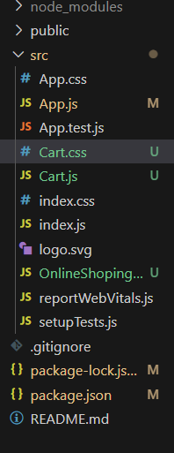

**Code for Cart.js:**

import React from 'react';

import './Cart.css';

class Cart extends React.Component {

  render() {

    const { cartInfo } = this.props;

    return (

      <div className="container">

        <h1 className="title">Items Ordered :</h1>

        <table className="cart-table">

          <thead>

            <tr>

              <th>Name</th>

              <th>Price</th>

            </tr>

          </thead>

          <tbody>

            {cartInfo.map((item, index) => (

              <tr key={index}>

                <td>{item.name}</td>

                <td>{item.price}</td>

              </tr>

            ))}

          </tbody>

        </table>

      </div>

    );

  }

}

export default Cart;

**Code for Cart.css:**

.container {

  text-align: center;

  margin-top: 50px;

}

.title {

  color: green;

  font-weight: bold;

}

.cart-table {

  margin: 20px auto;

  border-collapse: collapse;

  width: 300px;

  box-shadow: 0 0 5px #999;

}

.cart-table th,

.cart-table td {

  border: 1px solid #999;

  padding: 10px;

  color: teal;

  font-weight: 500;

}

.cart-table th {

  background-color: #e0f2f1;

  color: green;

  font-weight: bold;

}

**Code for OnlineShoping.js:**

import Cart from "./Cart";

import React from 'react';

export class OnlineShopping extends React.Component {

  render() {

    const cartIntfo=[{

        id: 1,

        name: 'Laptop',

        price: 1000

        }, {

        id: 2,

        name: 'Smartphone',

            price: 500

        }, {

        id: 3,

        name: 'Headphones',

        price: 100

    }]

    return (

      <div>

        <h1>Online Shopping</h1>

       <Cart cartInfo={cartIntfo} />

      </div>

    );

  }

}

**Code for App.js:**

import React from 'react'

import { OnlineShopping } from './OnlineShoping'

const App = () => {

  return (

    <>

    <OnlineShopping />

    </>  )

}

export default App

**Output:**

